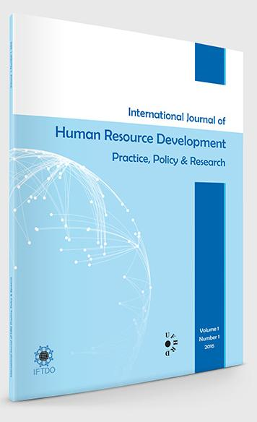
International Journal of HRD Practice, Policy & Research
Call for Contributions

This is a call for papers for the newly launched International Journal of HRD Practice, Policy & Research.
The Editors are interested in three types of paper – summarised briefly below. Specifically, we are interested in contributions which are:
- scholar - practitioner authored or from a partnership of academic / practitioner collaboration. The latter could have a practice / policy orientation or reflect joint research. Contributions from students who have recently completed (or are approaching completion) a DBA, for example, together with their supervisor might be a particularly apposite as regards the journal’s aspirations and interests

- international – either by virtue of the authors location or, preferably, in terms of the focus of the paper
Evidence-based HRD practice. These articles will focus on accounts of practice – interventions, programmes and events – but which can be constructed to make a contribution of interest to a broader HRD practice community. These articles could address a wide range of HRD interventions at different organisational levels (see also indicative topic areas below). Case study type articles are welcome. All such articles should consider impact in terms of factors such as the transfer of learning and implications for the development of HRD practice.
Evidence based policy and/ or implications for policy both within organizations and at national and international levels. These articles could address, for example, skills policies, strategic workforce development, the labour market, education – work transition, demographic changes and challenges. As with Type 1 submissions, case studies are welcome but also cross cultural comparisons and reviews which move beyond one organisation or country. Articles should be constructed to move beyond description so as to include review, assessment and considered questioning of the policy(ies) under consideration.
Applied research. These articles will report either results of empirical research and / or develop theoretical perspectives. Such articles will contribute to knowledge and understanding about HRD and closely related subject areas.
Topic areas to be addressed via the three types of paper include…….
- Strategic HRD in practice  - Talent Management  - HRD and workforce skills and development  - HRD practice in different sectors (private, public, voluntary)  - National and Sector HRD / VET policy and practice  - Contemporary issues in HRD (e.g. HRD vis Innovation, Technology, Diversity, Young People, Older Workers) | - HRD implications vis organisational change, mergers, takeovers etc  - Efficacy of organisational HRD interventions  - The HRD knowledge base (learning; skill; competencies)  - HRD Analytics  - HRD and Ethics  - The professionalisation of HRD  - HRD training and career development  - The teaching and learning of HRD

However, this list is indicative and interested contributors are encouraged to contact the editors to discuss their interests.

Volume 1, Issue 1
The inaugural issue of the journal has now been published. It includes:
- HRD and Organizational Change: Evidence-Based Practice; Bob Hamlin, University of Wolverhampton, UK
- Reconnecting Leaders to Organization Cultures; Jeff Gold, York St John University, UK
- Apprenticeship Management at National and Company Levels: Research Based ‘Good Practice’ Principles; Erica Smith, Federation University, Australia
- Developing Talent Strategies: Research Based Practice in Oman; Paul Turner, Leeds Business School, UK; Alison Glaister, The York Management School, UK; Rayya Al Amri, University of Bradford School of Management, UK
- Team-based Knowledge Sharing: Learning through Complex Work Challenges; Roland Yeo, John Stubbs and Martin Barrett, Saudi Aramco, Saudi Arabia
- Development Assessment Centres: Practice Implications Arising from Exploring the Participant Voice; Adam Turner, Health Education England (National Health Service, UK); Lynn Nichol, University of Worcester, UK

These articles are available to download on the journal’s dedicated web site: www.ijhrdppr.com Editor contact details are also available on the web site, together with guidelines for contributors.

Next Issue
Issue 2 will be published in October and the deadline for copy to be considered for Issue 2 is 30 June. The editors welcome enquiries from anyone interested in submitting to the journal.



The Journal is published by a partnership of the UFHRD and the IFTDO. The combined memberships of UFHRD and IFTDO provide the journal with a global readership and across all organisational sectors.

