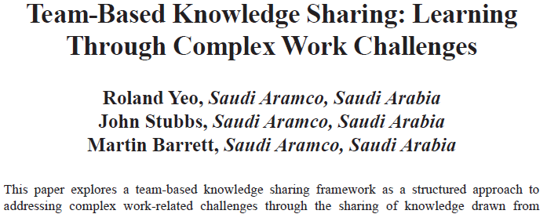
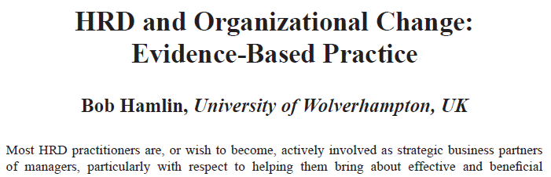
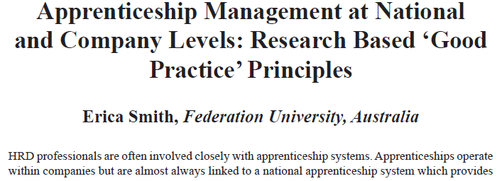


Get your HRD practice internationally recognised…..
Are you:
- engaged in HRD practice which is successful, innovative, challenging, influential, problematic?
- engaged in HRD research with an academic partner?
- involved in any aspect of HRD policy development (corporate, national, international)?
then the Journal would be interested to hear from you.

The International Journal of Human Resource Development Practice, Policy & Research is an open access, international peer reviewed journal. The Journal aims to publish articles which make an original contribution to Human Resource Development, providing insight, ideas and understanding on the contemporary issues and challenges facing HRD. It is a practice centred journal but one which seeks reflective consideration of HRD practice of interest to a wide range of HRD professionals.

See www.ihhrdppr.com for more details
or contact the Editor at R.J.Holden@ljmu.ac.uk

International Journal of
Human Resource Development
Practice, Policy & Research

